The Dawn of Artificial Intelligence
I just returned from the spring Finovate conference in Santa Clara, California. If you’ve never been to Finovate I would describe the event as speed dating with fintech companies. To cut through the clutter (and some of the hype!) presenters are put through a rigorous application process and if selected are given only seven minutes to provide a live demo of their product offerings. Over the two-day conference, 70 fintech companies showcased the very latest in financial technology innovations. Recurring themes were the power of data (data analytics) and the evolution of artificial intelligence (AI).
The power of big data is a concept that we are familiar with however I think we are only now just beginning to realize the potential of AI. Before I dive into present use cases, let’s warm up with a brief AI timeline.
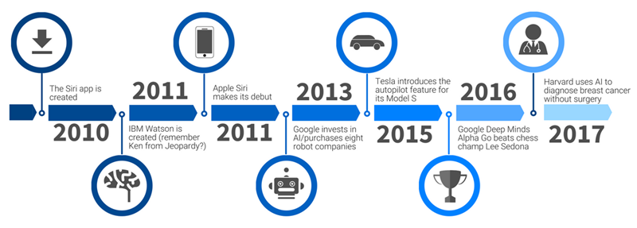
With so many possible applications, it’s hard to predict the path that AI will follow, but we can, and should, examine present-day use cases to see where things are heading.
Finance
Loans - AI is used to expedite loan applications and determine the right loan to apply for.
Chatbots - A chatbot is a computer program designed to simulate simple conversations with humans over the Internet. Chatbots are being used for password resets and account inquiries.
E-Commerce
Personal Shoppers - AI is used to help online shoppers find the perfect product.
Optimization - Websites and search engines are using AI for things like product placement and recommendations.
Health Care
Diagnosis - I already mentioned how AI is being used to diagnose cancer. It is also being used to identify sepsis in ICU patients before they show any symptoms, reducing fatality rates.
Test Results - AI can analyze things like lab results, MRIs, cat scans, and x-rays faster and more accurately than humans.
Agriculture
Grow Boxes - AI is being used to grow disease-free crops that are nearly perfect by measuring and controlling light, temperature, and moisture.
Crop Health and Harvesting - AI can identify weeds, deficiencies in soil, plant disease, and optimal harvest times. AI robots are used to spray the weeds, treat diseased plants, and pick the crops.
A growing number of industries are using AI and big data to do things faster with more accuracy and at lower costs. We are already seeing the deployment of chatbots and self-service technologies as a means of freeing up front line/call center staff from routine support requests. In fact, one of the Best in Show winners at Finovate was Conversation.one, a platform for conversation apps that companies can use to build and publish voice and chatbots with no programing, coding or complex integration.
In this dawning era of artificial intelligence, community banks will have many choices about how they deploy this new technology. Some banks will no doubt eschew bots and digital lending in favor of decisions made by real-life human beings, but others will opt for service that is always on. Either way, there will be an opportunity for community banks to differentiate themselves by offering the digital experience that best suits the expectations and needs of their customers, coupled with the unparalleled customer service and quality financial products for which community banks are known.

