February 2024 Issue
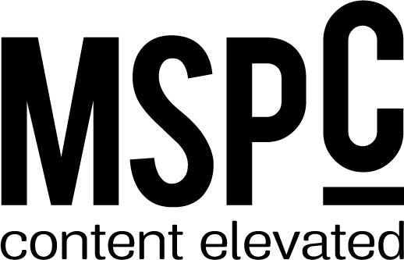

Flourish/From the Top
People: Rebecca Romero Rainey, Derek Williams, Lucas White
Banks: Century Bank & Trust in Milledgville, Ga.
Initiatives: ICBA LIVE 2024, ICBA ThinkTECH programs, ICBA ThinkTECH Accelerator, ICBA Community

Currencies
People: None
Banks: Legends Bank in Clarksville, Tenn., EntreBank in Bloomington, Minn., M&F Bank in Durham, N.C., Chickasaw Community Bank in Oklahoma City
Initiatives: ICBA ThinkTECH Accelerator, ICBA LIVE 2024
Social Network Banks: Valley Bank in Morristown, N.J., The Bank of Monroe in Union, W. Va.

Portfolio
Parsing the proliferation of payments
People: Lance Noggle
Banks: Bank Independent in Sheffield, Ala.
Initiatives: ICBA Payments, ICBA ThinkTECH, ICBA LIVE

Schooling customers on student loan fraud
People: Steven Estep
Banks: None
Initiatives: None

Convening wth the spirit of more
People: Charles Potts
Banks: None
Initiatives: ICBA LIVE 2024, ICBA Expo, ICBA ThinkTECH Accelerator, ICBA ThinkTECH Accelerator Showcase, ICBA ThinkTECH in an Instant, ICBA Digital Transformation & Innovation Track

Sharing the load with participation loans
People: Chris Cole
Banks: Lumbee Guaranty Bank in Pembroke, N.C., Native American Bank in Denver
Initiatives: None

Final updates to debit card rules are here
People: Lance Noggle
Banks: None
Initiatives: None

Developing drive
People: Lindsay LaNore
Banks: None
Initiatives: None

What makes a good manager?
People: Valerie Utsey
Banks: Wesbanco Bank in Wheeling, W. Va.
Initiatives: ICBA LIVE 2024, ICBA Learning Labs, ICBA LEAD FWD Summit, ICBA webinars and pre-recorded classes, Engage with the Experts: banker Roundtable

The big chill
People: Jim Reber
Banks: None
Initiatives: ICBA LIVE Learning Labs, ICBA Securities

ICBA advocacy: the legislative year ahead
People: Paul Merski
Banks: None
Initiatives: ICBA Action Center

Features
Get ready for ICBA LIVE 2024
People: Rebecca Romero Rainey, Derek Williams, Lucas White
Banks: None
Initiatives: ICBA LIVE 2024, ICBA LIVE Roundtables, LICBA LIVE Learning Labs, ICBA LIVE ThinkTECH Accelerator Showcase, ICBA PAC, ICBPAC Annual Auction Fundraiser, ICBA Bank Director Current Issues Seminar, ICBA’s Preferred Service Providers

From vision to reality
People: None
Banks: Ponce Bank in the Bronx, N.Y., The Harbor Bank in Baltimore, Md., M&F Bank, Southern Bancorp in Arkadelphia, Ark., First Independence Bank in Detroit, Relyance Bank in White Hall, Ark., Encore bank in Little Rock, Ark.
Initiatives: None

New shoots with deep roots
People: Chris Cole
Banks: Texas Traditions Bank in Katy, Texas, Locality Bank in Fort Lauderdale, Fla., Community Unity Bank in Birmingham, Mich., EntreBank in Bloomington, Minn.
Initiatives: None

Connections
Unlocking the doors to homeownership
People: None
Banks: SouthState Bank in Winter Haven, Fla.
Initiatives: None

A half century of giving
People: None
Banks: CountyBank in Greenwood, S.C.
Initiatives: None

Be proactive with crisis preparedness

People: None
Banks: None
Initiatives: ICBA Foundation, ICBA Crisis Preparedness resources, ICBA Education’s IT Institute, ICBA Education’s Risk Management Institute, ICBA Education’s BSA/AML Institute

A bank culture that works
People: Charles Potts, Lindsay LaNore
Banks: Reliabank Dakota in Estelline, S.D., Ambler Savings Bank in Ambler, Pa.
Initiatives: Independent Banker: A Community Banking Podcast from ICBA

Out of Office
Banks: Veritex Community Bank in Dallas, Texas

