March 2022 Issue
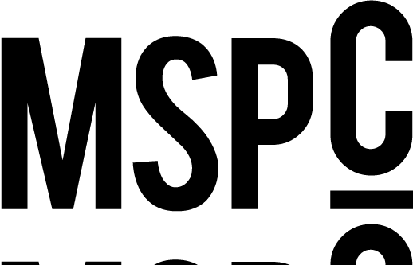

Flourish/From the Top
People: Rebecca Romero Rainey, Robert M. Fisher
Banks: Tioga State Bank in Spencer, N.Y.
Initiatives: ICBA LIVE
Independent Community Bankers Political Action Committee

Currencies
People:
Banks: Franklin Savings Bank in Franklin, N.H.
Initiatives: ICBA’s partnership with CISA
Social Network Banks: Horicon Bank in Horicon, Wis.
Vista Bank in Dallas, Texas
First Citrus Bank in Tampa, Florida
Capitol Federal Savings Bank in Topeka, Kan.

Portfolio
Six ways data can boost your community bank’s brand
People: Rob Birgfeld

An UDAAP update for 2022
People: Rhonda Thomas-Whitley

The impact of rewards and recognition
People: Lindsay LaNore
Valerie Utsey

Partners against cybercrime
People: Joel Williquette
Banks: Texas Bank and Trust Company in Longview, Texas

The laws of fintech attraction
Banks: MainStreet Bank in Fairfax, Va.
IncredibleBank in Wausau, Wis.
Rockland Trust Co. in Rockland, Mass.

The ups and downs of customer reviews
People: Rob Birgfeld
Banks: Northpointe Bank in Grand Rapids, Mich.

Unlocking better customer connections
People: Charles Potts
Initiatives: ICBA ThinkTECH 2.0
ICBA ThinkTECH Network Directory

March sanity
People: Jim Reber
Initiatives: ICBA LIVE
ICBA Securities’ partnership with Vining Sparks

Giving swag some swagger
Banks: CBI Bank & Trust in Muscatine, Iowa
Citizens Bank of Edmond in Edmond, Okla.
Tioga State Bank in Spencer, N.Y.

Back to Capitol Hill
People: Aaron Stetter
Initiatives: ICBA Capital Summit

Features
The spirit of independence
People: Brad Bolton
Banks: Community Spirit Bank in Red Bay, Ala.
Initiatives: ICBA LIVE

6 smart marketing moves for 2023
Banks: Lakeland Bank in Oak Ridge, N.J.

Leading with intention
Banks: Bank of Charlestown in W.Va.
Citizens Bank of Edmond in Okla.
Community 1st Bank Las Vegas in Las Vegas, N.M.

Connections
First Women’s Bank tackles small business inequity
Banks: First Women’s Bank in Chicago, Ill.

Building up its community
Banks: Community Bank of Oelwein in Oelwein, Iowa

Small solutions, big results
Banks: Queensborough National Bank and Trust Co. in Louisville, Ga.
Initiatives: ICBA LIVE
ICBA ThinkTECH Accelerator

Out of Office
Banks: Oklahoma Bank and Trust in Clinton, Okla.

